Docker Installation for windows

1. Download Docker desktop using the link <https://www.docker.com/products/docker-desktop>
2. Click on downloaded .exe file and install docker.
3. Once you install docker you need to change following settings in control panel

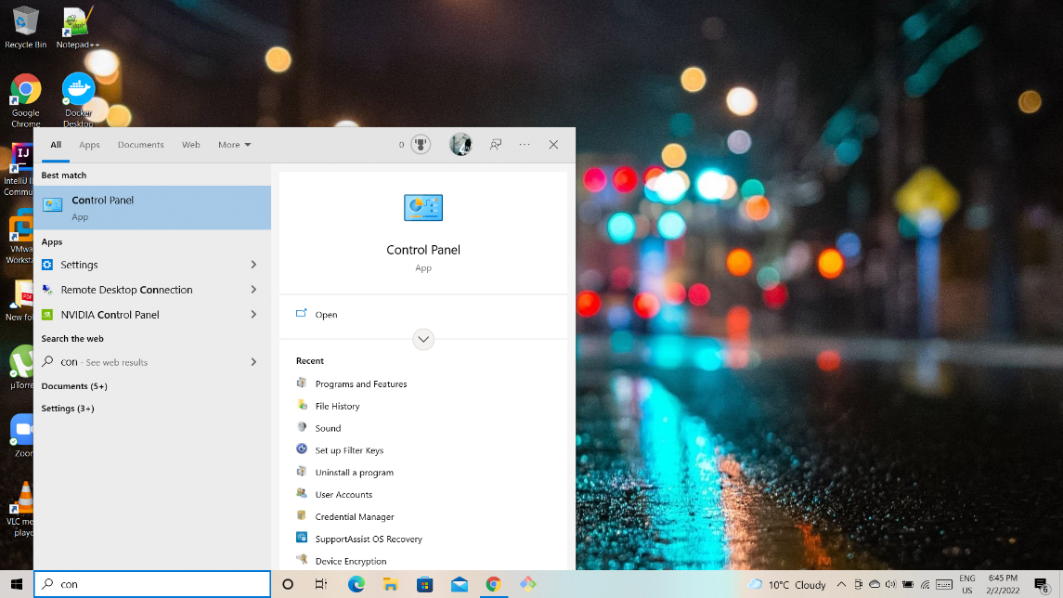

Search for control panel

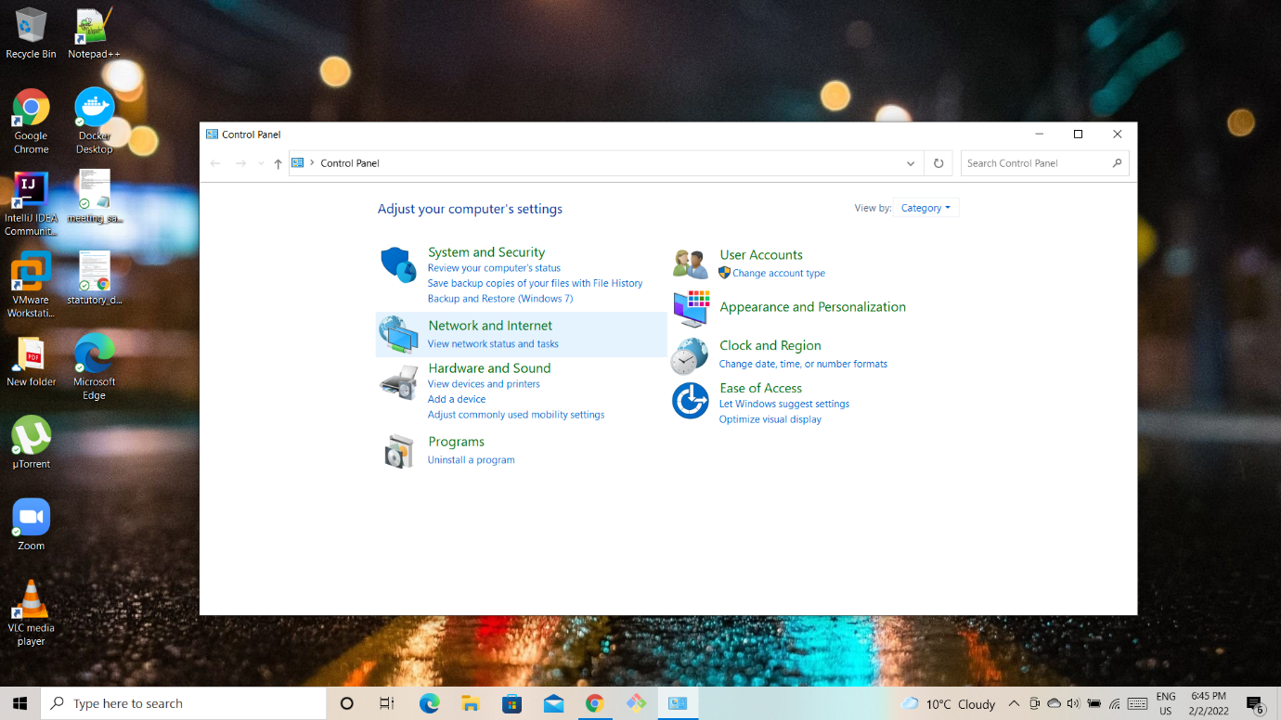



Click on programs

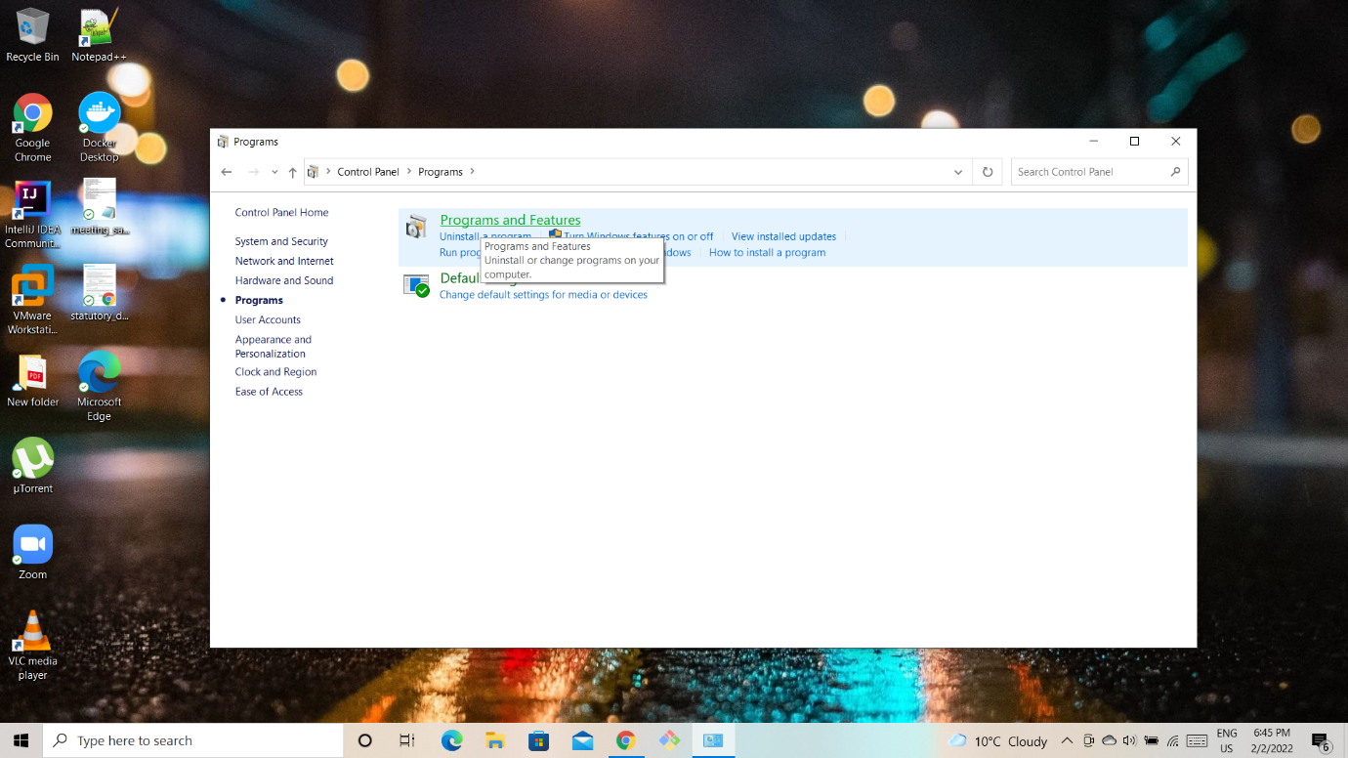



Click on Programs and features

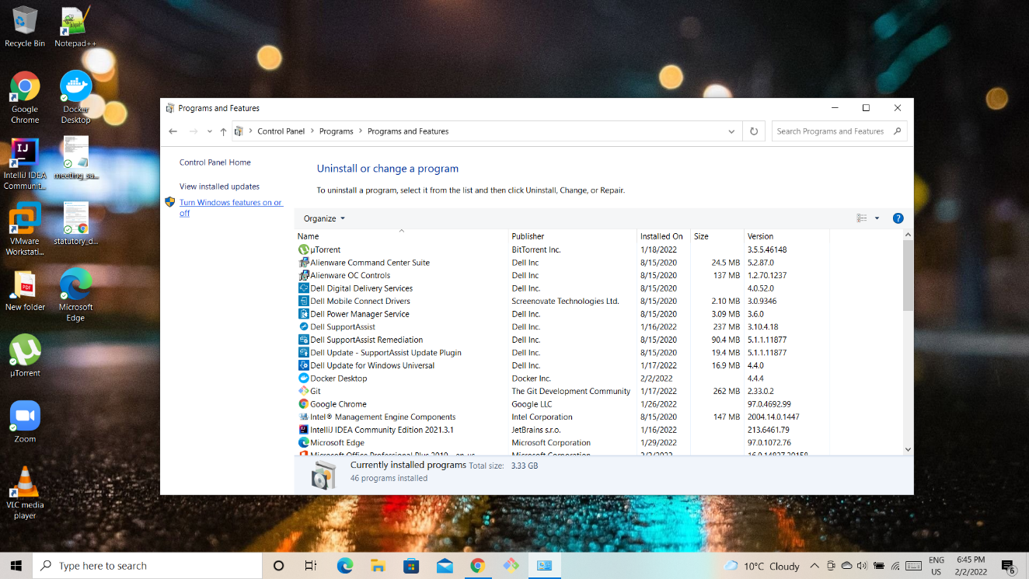Click on Windows features on or off



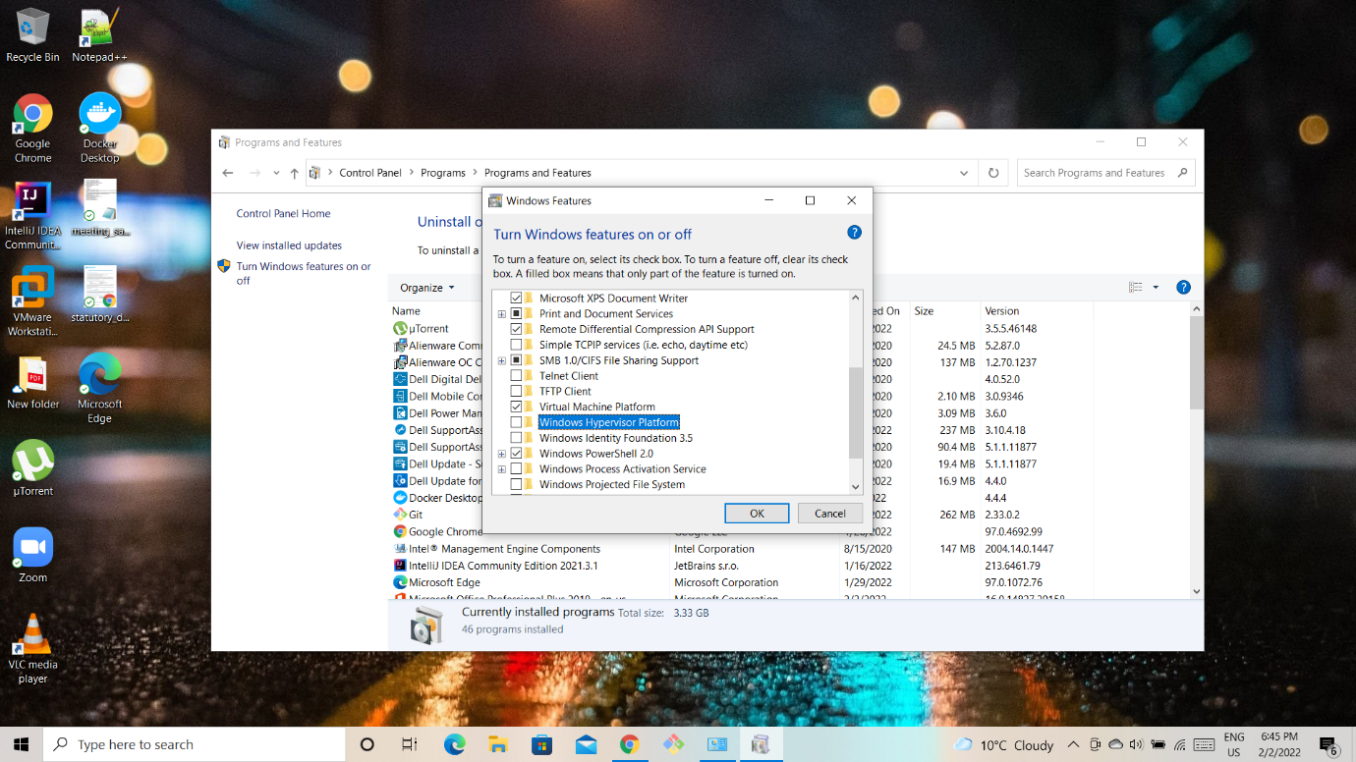

Select option Windows Hypervisor Platform and check the box and check virtual machine platform as well.

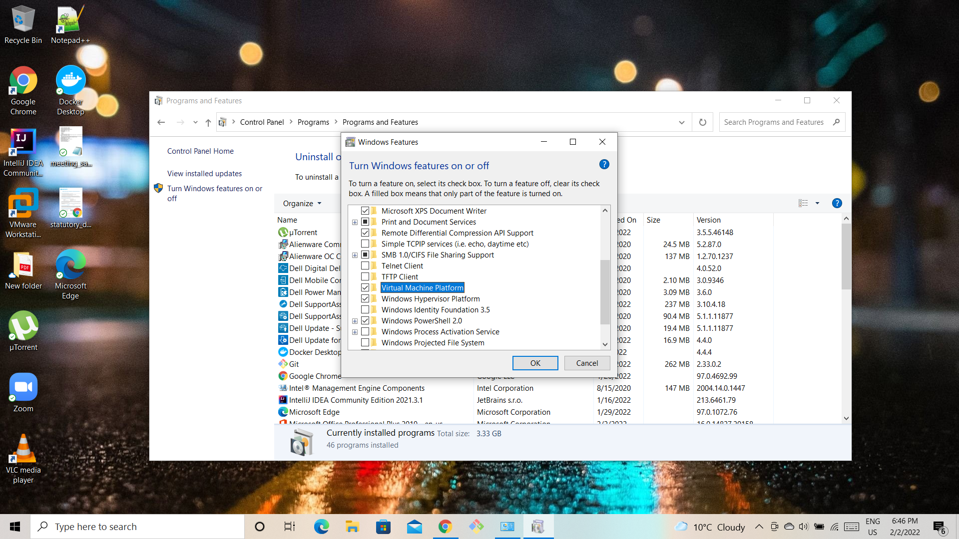

Once done click ok and restart system

Once you restart the system search for PowerShell in search bar and run as administrator

Follow these steps <https://docs.microsoft.com/en-us/windows/wsl/install-manual>

Once performed all the steps in powershell restart the system once again and run the docker desktop.

If its showing docker failed to start go to settings and check onall the options and click apply and restart.

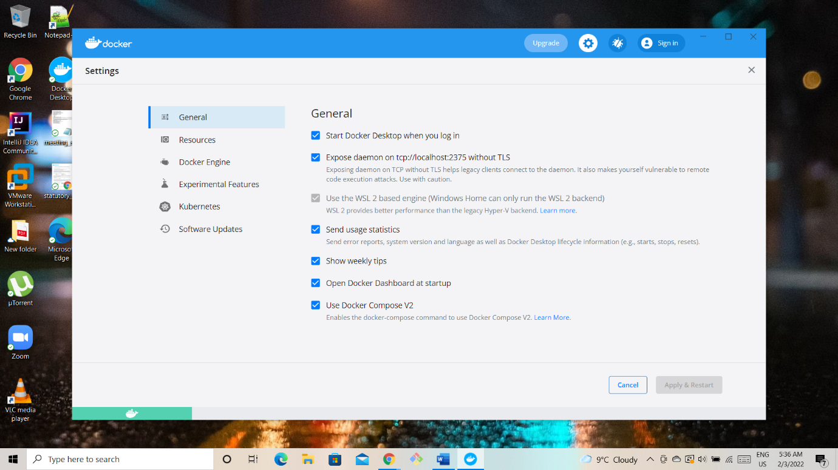

Close the application and restart the system again and now run docker desktop.